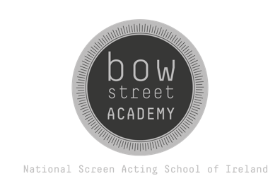
Young Screen Actors Booking Form
Student Details:
Name:
Age:
Date of Birth:
(Proof of Age must be included with your application)
Which Group are you signing up for:
13 - 17 yrs 11am - 1 pm ☐
13 – 17 yrs 2 pm – 4 pm ☐
ADVANCED GROUP 18 - 19 yrs 2 pm – 4 pm ☐
Have you taken part in a Bow Street Young Screen Actors term or Summer Camp before?
YES NO
If so, which did you attend?
Saturday Workshops
Summer Camp
If you have other Acting experience please outline below:

In promoting our workshops we make videos to show what we do. Do we have permission to use your child’s image in the making and promoting of our courses and workshops?:

Parent/Guardian Contact Details
Name:
Phone:
Email:
How did you hear about Bow Street Young Screen Actors Academy?
- WEBSITE ☐
- SOCIAL MEDIA ☐

PAYMENT INFORMATION:
**PLEASE DO NOT PAY THE FEE UNTIL WE HAVE CONFIRMED RECEIPT OF THE BOOKING FORM**
FEE: €380 (Full Amount Must be paid prior to attending the first class)
WE ACCEPT BANK TRANSFERS ONLY
OUR BANK DETAILS:
Bank: Bank of Ireland, Smithfield, Dublin 7
Sort Code: 90-00-92
Name on Account: Bow Street Training LTD
Account Number: 77921481
IBAN: IE17 BOFI 9000 9277 9214 81
BIC Code: BOFIIE2D

***IMPORTANT***
PLEASE ENSURE THAT YOU USE YOUR FULL NAME AS A REFERENCE WHEN TRANSFERRING FUNDS DIRECTLY TO US. OTHERWISE WE MAY NOT BE ABLE TO TRACK YOUR PAYMENT. IN THE UNLIKELY EVENT THAT PROVIDING A NAME AS REFERENCE IS NOT POSSIBLE, PLEASE EMAIL US THE UNIQUE TRANSFER CODE PROVIDED BY THE BANK - TO: info@bowstree.ie
Please return completed booking form to training@bowstreet.ie
"Bow Street Academy for Screen Acting reserves the right to cancel or postpone any training course with prior written (email) notice. In the unlikely event of any course being postponed or cancelled, you can choose to have your fee payment deferred to the next available course or a full refund can be provided if you wish.”

