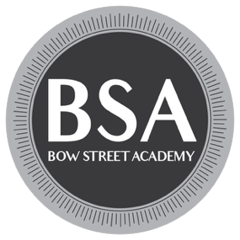
Hilton House, 3 Ardee Rd, Rathmines, D06 FK18, Ireland.
6 Month Part Time Application Form
Name:

Address:

Date of Birth (must be 18+ at start of course):

Email:

Contact Number:

If you have previous actor training, please outline below:
(Please note this is not essential to apply)

If you have other acting experience, please outline below:

Reminder of items to submit:
Application Form
CV
Cover Letter
Headshot of similar photo (Portrait)

APPLICATION FEE: €30
*WE ONLY ACCEPT PAYMENTS BY BANK TRANSFER*
BANK DETAILS:
Bank: Bank of Ireland, Smithfield, Dublin 7
Sort Code: 90-00-92
Name on Account: Bow Street Training LTD
Account Number: 77921481
IBAN: IE17 BOFI 9000 9277 9214 81
BIC Code: BOFIIE2D

***IMPORTANT***
PLEASE ENSURE THAT YOU USE YOUR FULL NAME AS A REFERENCE WHEN TRANSFERRING FUNDS DIRECTLY TO US. OTHERWISE WE MAY NOT BE ABLE TO TRACK YOUR PAYMENT. IN THE UNLIKELY EVENT THAT PROVIDING A NAME AS REFERENCE IS NOT POSSIBLE, PLEASE EMAIL US THE UNIQUE TRANSFER CODE PROVIDED BY THE BANK - TO: training@bowstreet.ie

